Predicting the Remaining Useful Life (RUL) of a Turbofan Jet Engine

Tareq Alaa Alsahaf
Maintenance and Reliability, Industrial Systems Engineering
King Fahd University of Petroleum and Minerals
Dhahran - Saudi Arabia
g202036800@kfupm.edu.sa

Abstract
Predicting the Remaining Useful Life (RUL) of turbofan engines is critical for effective maintenance planning and ensuring operational safety in aviation. This study utilizes the NASA C-MAPSS dataset, which contains multivariate time-series sensor data from multiple engines under varying operating conditions. A machine learning approach is applied to model engine degradation and estimate RUL, enabling timely maintenance decisions. The proposed methodology includes data preprocessing, feature extraction, and regression-based prediction models. Results demonstrate the model’s ability to accurately forecast RUL, potentially reducing unplanned downtime and maintenance costs. This work provides a framework for implementing predictive maintenance strategies in aerospace applications.
Introduction
The data set under study consists of operational and sensor measurements from turbofan jet engines, collected to support predictive maintenance and reliability analysis. Performing data-driven analysis on such equipment is critical because early detection of anomalies and remaining useful life (RUL) estimation can significantly improve operational efficiency and reduce unexpected failures. Asset Performance Management (APM) plays a crucial role in the industry by leveraging this data to monitor, maintain, and optimize the performance of critical assets. Implementing APM strategies helps minimize downtime, avoid costly operational disruptions, extend equipment lifespan, and reduce maintenance expenses, while also enhancing safety by identifying potential failure risks before they become critical. Overall, analyzing these datasets provides actionable insights that enable industries to maximize operational time, improve decision-making, and maintain high standards of reliability and safety in complex machinery, similar to jet engines.

Problem Characterization

Define the Problem and Summarize Its Importance
This graph illustrates the projected growth of Saudi Arabia’s predictive maintenance market, highlighting the importance of accurately predicting the Remaining Useful Life (RUL) of industrial assets such as turbofan jet engines. Effective RUL estimation enables predictive maintenance, a core component of Asset Performance Management (APM), which maximizes operational time, reduces maintenance costs, extends asset lifespan, and enhances safety.

Challenging Aspects
Accurate RUL prediction is challenging due to nonlinear and time-dependent degradation of components, variations in operational conditions, and sensor noise. Additionally, initial wear and manufacturing variations between engines are ignored, adding further uncertainty to model predictions.

Relevant Statistics to Illustrate the Scope and Impact
Ineffective maintenance strategies can reduce an asset’s productive capacity by 5% to 20%, while unplanned downtime costs industries roughly $50 billion annually (Deloitte, 2017). The graph bellow illustrates the growing investment in predictive maintenance in Saudi Arabia as a response to these industrial losses, underscoring the critical need for accurate RUL estimation.
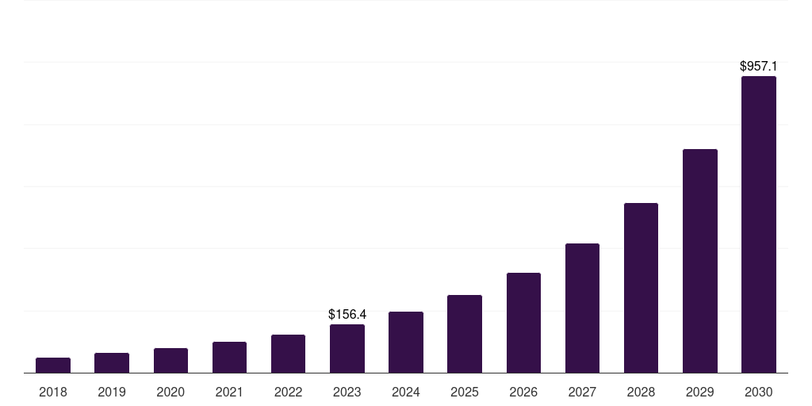
Figure 1: Saudi Arabia predictive maintenance market, 2018-2030 (US$M)

Problem Formulation & Modeling

Mathematical Model
The problem can be mathematically represented as a regression problem as follows:
$$X(t)=[x_{1}(t),x_{2}(t),...,x_{n_{s}}(t)]$$
$X(t)$: Vector of sensor measurements at time $t$.
$$C(t)=\left[c_{1}(t),c_{2}(t),c_{3}(t)\right]$$
$C(t)$: Vector of operational settings (control factors) at time $t$.
$N(t)$: Noise or unmodeled variations.
$RUL(t)$: Remaining Useful Life (RUL), output.
Then the system can be represented as:
$$RUL(t)=f( X\left(t\right) ,C\left(t\right) ,N\left(t\right) )$$
Where $f$is an unknown function that maps sensor data and operating conditions to RUL. The goal is to train a model to learn $f$ in order to predict RUL for unseen future values.

Parameter Diagram (P-Diagram)
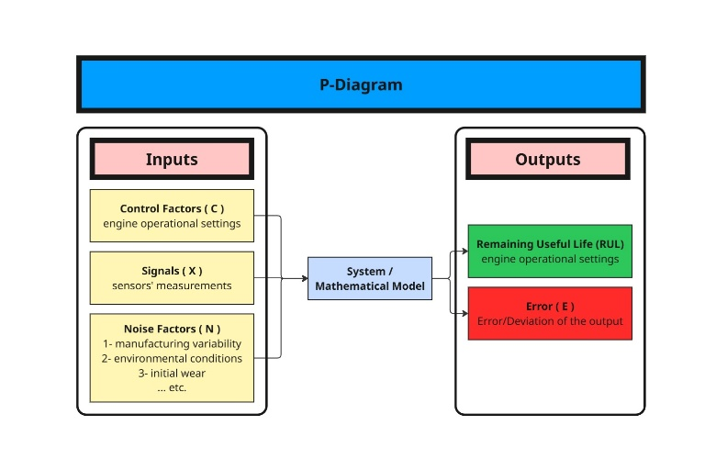
Figure 2: P-Diagram according to NASA Turbofan Jet Engine Data Set

Literature Review & Critical Analysis
Remaining Useful Life (RUL) prediction of turbofan jet engines is a core task in Prognostics & Health Management (PHM). Accurate RUL estimation enables optimized maintenance scheduling, reduces unexpected failures, and improves reliability. In recent years, the NASA C-MAPSS simulation dataset has become the standard benchmark for data-driven RUL research due to its multi-sensor, multi-condition degradation trajectories. This survey briefly reviews several trusted and highly cited approaches that align closely with the methodology used in this project. The focus is on simple, practical comparisons of machine-learning and heuristic-based strategies, highlighting their advantages, disadvantages, and performance under common criteria such as data source, scalability, benchmarking, and real-time suitability.

LSTM-Based RUL Prediction
Ellefsen et al. (2019) applied Long Short-Term Memory (LSTM) networks to model non-linear temporal degradation patterns in turbofan engines using the C-MAPSS dataset. LSTM demonstrated strong baseline accuracy due to its ability to capture long-term dependencies in sensor sequences.

Advantages:
- Learns temporal degradation effectively.
- Outperforms traditional ML (e.g., SVR, Random Forest).
- Widely accepted benchmark.

Disadvantages:
- Weak scalability on multi-condition datasets (FD002–FD004).
- High training time.
- No real-time evaluation.

CNN + Attention Networks
Muneer et al. (2021) proposed a 1-D CNN with an attention mechanism to prioritize critical time steps in sensor data. This method reduces training cost compared to LSTM while achieving competitive accuracy on FD001.

Advantages:
- Faster training and simpler structure.
- Improved interpretability via attention.
- Good accuracy on single-condition data.

Disadvantages:
- Performance decreases in multi-regime datasets.
- Still fully dependent on C-MAPSS simulation.
- Real-time execution not addressed.

Hybrid CNN-LSTM-Attention Models
Deng et al. (2024) introduced a hybrid architecture combining CNN, LSTM, and attention layers. This framework showed improved robustness across all four C-MAPSS subsets, making it stronger under varied environmental conditions.

Advantages:
- High accuracy across FD001–FD004.
- Captures local features + long-term trends.
- Strong scalability to noise and varying conditions.

Disadvantages:
- Increased computational load.
- Complex architecture; difficult to deploy.
- No real-time performance study.

Domain-Adaptation-Based RUL Prediction
Nejjar et al. (2023) employed domain adaptation on the N-CMAPSS dataset to address realistic variations in engine operating regimes. Their approach aligns training and testing distributions using adversarial learning.

Advantages:
- Best scalability under domain shift.
- More realistic multi-flight-profile modeling.
- Strong robustness to varying environments.

Disadvantages:
- Complex and computationally heavy.
- Still based on simulated data.
- Not suitable for real-time embedded systems.

Comparative Evaluation
Method | Data Source | Scalability | Benchmarking | Real-Time Suitability
LSTM | C-MAPSS | Weak for multi-condition | Compared with ML baselines | Low
CNN  + Attention | C-MAPSS | Moderate | Compared with CNN/LSTM | Moderate
CNN-LSTM-Attention | C-MAPSS | Strong across FD001–FD004 | Ablation studies | Low
Domain Adaptation | N-CMAPSS | Excellent | Compared with DA methods | Low

Across all studies, deep learning remains the dominant approach for turbofan RUL prediction. LSTM models provide simple and strong baselines but lack robustness under varying operational conditions. CNN-based attention models are faster and more interpretable but limited to simpler datasets. Hybrid CNN-LSTM-attention networks deliver the best accuracy and scalability, though at the cost of higher computational complexity. Domain-adaptation methods offer the best generalization performance but require sophisticated training procedures and remain unsuitable for real-time deployment. A common limitation across all works is their dependence on simulated C-MAPSS or N-CMAPSS data, with very limited validation on real-world engine fleets.

Industry Practices and Practical Approaches to Jet-Engine RUL Prediction
In the aviation industry, the estimation of Remaining Useful Life (RUL) for turbofan engines is approached very differently from academic studies that rely heavily on the NASA C-MAPSS dataset. Engine manufacturers such as GE Aerospace, Rolls-Royce, Pratt & Whitney, and Safran deploy large-scale Health & Usage Monitoring Systems (HUMS) that collect real-time operational data—including exhaust gas temperature (EGT) margin, fuel flow, vibration signatures, oil debris analysis, and performance deterioration trends. Instead of depending on a single deep-learning model, industrial RUL estimation relies on a combination of physics-based degradation models, engineering domain knowledge, and fleet-wide statistical analytics. For example, Rolls-Royce’s Power-by-the-Hour model uses thermodynamic performance margin tracking (especially EGT margin decay) combined with historical maintenance records to evaluate when components such as compressor blades, turbine blades, bearings, or combustor liners will reach their end of life. GE’s Prognostics Engine Health Management (EHM) systems use a blended approach of simplified physics models (e.g., compressor efficiency decay, turbine creep life estimation) and anomaly detection algorithms fed from vibration and performance data logged during each flight cycle.
A key difference from academic methods is that industry rarely performs direct RUL regression. Instead, they focus on condition indicators (CIs)—such as corrected core speed, pressure ratios, EGT margin, or vibration amplitudes—and track their rate of change over time. These CIs feed into physics-informed rules or statistical thresholds that trigger maintenance actions. In high-risk components like turbine blades, companies rely on creep and fatigue damage accumulation models, often based on finite-element thermal analysis and stress modeling, rather than deep learning. Machine learning is used, but typically in supportive roles such as anomaly detection, clustering of abnormal behaviors, sensor fusion, or trend extrapolation, rather than full end-to-end RUL prediction. Moreover, industry must ensure certification, safety, and explainability, which makes black-box deep networks difficult to deploy without extensive validation. Thus, interpretability, reliability, and regulatory compliance often outweigh raw accuracy. In summary, while academia explores increasingly complex deep learning architectures for RUL, real aviation practice favors hybrid frameworks that combine physics models, engineering knowledge, and conservative statistical monitoring to ensure safety and regulatory acceptance.

Limitations of Current Research vs. Real-World Needs
Although academic research in RUL prediction—particularly using the NASA C-MAPSS dataset—has advanced rapidly through deep neural networks, significant gaps remain when these models are compared with the requirements of real aviation operations. First, the vast majority of published work relies solely on simulated datasets, meaning the learned models do not capture the full complexity of real turbine engines, such as sensor drift, maintenance actions, variable fuel quality, environmental effects, or operational irregularities. Real engines operate under diverse mission profiles, and their degradation patterns seldom follow the clean trends seen in C-MAPSS. This creates a major generalization gap, making most academic models unsuitable for direct deployment in safety-critical environments.
Second, RUL models in the literature often pursue high prediction accuracy, but aviation industry standards demand interpretability, traceability, and certification. Regulatory bodies (FAA, EASA) require maintenance-related decision-making tools to provide transparent reasoning and to adhere to strict safety margins. However, deep learning architectures such as LSTM, CNN-LSTM, and transformer-based models remain largely black-box systems, making them difficult to certify. Industry therefore prefers hybrid approaches—combining physics-based degradation modeling with statistical indicators—because these methods align better with engineering intuition and allow engineers to justify decisions such as early removals or on-condition maintenance.
A third limitation is that academic studies rarely consider real-time constraints. Engine health monitoring systems used by Rolls-Royce, GE Aerospace, and Pratt & Whitney require fast inference, low power consumption, and reliable operation on embedded avionics or ground-based decision platforms. In contrast, many research models require large GPUs, long training durations, and heavy preprocessing pipelines that cannot be integrated into operational maintenance systems. Furthermore, academic work often overlooks fleet-level analytics, historical maintenance logs, and operational metadata—resources heavily used by industry. OEMs track parameters such as exhaust gas temperature (EGT) margin decay, core speed deterioration, vibration anomalies, and oil debris signatures over thousands of engines worldwide, whereas academic models usually analyze only isolated sensor sequences.
In summary, while current research pushes the boundaries of algorithmic performance, it does not yet address the broader ecosystem of aviation maintenance: regulatory compliance, real-world noise, mixed data sources, interpretability, and scalable deployment across global fleets. Bridging these gaps requires not only improved machine learning techniques but also the integration of physics knowledge, domain expertise, and system-level engineering considerations used by industry leaders.
References
- B². (2018, October 2). NASA Turbofan Jet Engine Data Set [Data set]. Kaggle. https://www.kaggle.com/datasets/behrad3d/nasa-cmaps/data
- The P-Diagram for the system was developed using the Miro online whiteboard (https://miro.com).
- Deloitte. (2017). Predictive maintenance and the smart factory. Retrieved from https://www.deloitte.com/us/en/services/consulting/services/predictive maintenance-and-the-smart-factory.html .
- Grand View Research. (2025). Saudi Arabia Predictive Maintenance Market Size & Outlook. Retrieved https://www.grandviewresearch.com/horizon/outlook/predictivemaintenance-market/saudi-arabia .
- T. Ellefsen, M. B. Dwyer, K. S. Kahl, and D. M. Nicholson, “Remaining useful life predictions for turbofan engines using LSTM networks,” Reliability Engineering & System Safety, vol. 183, pp. 248–264, 2019. doi: 10.1016/j.ress.2018.11.011.
- M. Muneer, A. Athar, M. U. Ghani, and M. A. Jaffar, “Data-driven deep learning-based attention mechanism for remaining useful life prediction: Case study application to turbofan engine analysis,” Electronics, vol. 10, no. 20, p. 2453, 2021. doi: 10.3390/electronics10202453.
- Z. Deng, X. Yan, S. Li, and Z. Zhao, “Prediction of remaining useful life of aero-engines based on CNN–LSTM–attention,” Discover Mechanical Engineering, vol. 2, no. 1, 2024. doi: 10.1007/s44196-024-00639-w.
- A. Nejjar, B. Chebel-Morello, and N. Zerhouni,
“Domain adaptation via alignment of operation profile for remaining useful lifetime prediction,” arXiv preprint arXiv:2302.01704, 2023.
- M. Arias-Chao, C. Kulkarni, K. Goebel, and O. Fink, “Aircraft engine run-to-failure dataset under real flight conditions for prognostics and diagnostics,” Data, vol. 6, no. 1, 2021. doi: 10.3390/data6010005.
- M. Salinas-Camus, J. Chacón-Rivas, and A. Pérez, “Uncertainty in aircraft turbofan engine prognostics on the C-MAPSS dataset,” Proceedings of the PHM Society Conference, vol. 16, no. 1, 2024.
- A. D. Kwakye, “Platform health management for aircraft maintenance,” Proc. Inst. Mech. Eng. Part G: J. Aerospace Engineering, 2024. doi: 10.1177/09544100231219736.
- M. A. Chao, O. Fink, and K. Goebel, “Fusing physics-based and deep learning models for prognostics of complex systems,” Reliability Engineering & System Safety, vol. 217, 2022.
doi: 10.1016/j.ress.2021.107722.
- I. de Pater, P. van Houtum, and G. J. van Houtum, “Alarm-based predictive maintenance scheduling for aircraft engines with imperfect remaining useful life prognostics,” Reliability Engineering & System Safety, vol. 222, 2022. doi: 10.1016/j.ress.2022.108341.
- C. Peng, X. Liu, and Z. Hu, “Remaining useful life prognosis of turbofan engines based on the C-MAPSS dataset,” Scientific Reports, vol. 12, Article 7072, 2022. doi: 10.1038/s41598-022-10191-2.
- Rolls-Royce plc, “Intelligent Engine Health Monitoring (EHM),” 2019. Available: https://www.rolls-royce.com/media/our stories/discover/2019/intelligent-engine-health-monitoring.aspx
- K. Hemmerdinger, “The power of engine health information,” Aviation International News (AINonline), Apr. 26, 2024. Available: https://www.ainonline.com/aviation-news/business-aviation/2024-04-26/power-engine-health-information
- GE Aerospace, “Health and Usage Monitoring System (HUMS),”2023. Available: https://connectedaircraftsupport.geaviation.com/support/solutions/articles/43000537206-health-and-usage-monitoring-system-hums-
- Rolls-Royce,“Engine Health Management,” Ingenia, Issue 39, June 2009. Available: https://www.ingenia.org.uk/articles/engine-health-managment/
- Gabelli Funds, “Power-by-the-Hour: The Rolls-Royce business model,” 2019. Available: https://gabelli.com/research/airplanes-power-by-the-hour/

